Formatting Papers for the Journal of Engineering Education Transformations (JEET)
(Leave this section as is for the double-blind review process) First A. Author, Second B. Author, and Third C. Author, Jr.
Abstract—These instructions give you guidelines for preparing papers for the Journal of Engineering Education Transformations (JEET). This template is based on the IEEE Transactions template. Use this document as a template if you are using Microsoft Word 6.0 or later. Otherwise, use this document as an instruction set. Paper titles should be written in uppercase and lowercase letters, not all uppercase. Avoid writing long formulas with subscripts in the title. The abstract must be a concise yet comprehensive reflection of what is in your article. An abstract needs to be written in a way that it captures the attention of a potential reader and gives them enough information to know that the paper is relevant and leaves them wanting to explore the paper in more detail. In particular, the abstract must be self-contained, without abbreviations, footnotes, or references. It should be a microcosm of the full article. The abstract must be between 150–250 words. Be sure that you adhere to these limits; otherwise, you will need to edit your abstract accordingly. The abstract must be written as one paragraph and should not contain displayed mathematical equations or tabular material. The abstract should include three to six different keywords or phrases, as this will help readers to find it. It is important to avoid over-repetition of such phrases as this can result in a page being rejected by search engines. Ensure that your abstract reads well and is grammatically correct.

Keywords—Enter three to six keywords or phrases in alphabetical order, separated by semi-colons.

JEET Category—Choose one: Research, Practice, or Op-Ed. (Please note, Op-Eds are by invite only. Refer to the Paper Submission and Review Guidelines for more details.)

INTRODUCTION
T
HIS document is a template for Microsoft Word versions 6.0 or later. If you are reading a paper or PDF version of this document, please download the electronic file,
jeet-template.docx, from the JEET Web site at http://www.journaleet.org/index.php/jeet/pages/view/rg so you can use it to prepare your manuscript.

Guidelines For Manuscript Preparation
When you open jeet-template.docx, select “Print Layout” from the “View” menu in the menu bar (View | Page Layout) (these instructions assume MS Word 6.0. Some versions may have alternate ways to access the same functionalities noted here). Then, type over sections of jeet-template.docx or cut and paste from another document and use markup styles. On the “Home” ribbon, click on the “Styles Pane” button to open the Styles as a sidebar. It will show you the “Current style” (for example, the style at this point in the document is “Text”) as well as a list of predefined styles to apply from. Highlight a section that you want to designate with a specific style, and then select the appropriate name on the style menu. The style will adjust your fonts and line spacing. Do not change the specific details of the styles such as font size and spacing. Use italics for emphasis; do not underline. Use Times New Roman font throughout the manuscript. See Table I for a summary of styles used in this template.
An associate editor may ask you to resubmit the manuscript without assigning reviewers if it is not in the proper format. This document talks only about the formatting of the paper. For guidelines on the content and structure of the article and review criteria, please visit Author and Reviewer Guidelines (http://www.journaleet.org/index.php/jeet/pages/view/rg).

Word limits
The manuscript pages are expected to have between 4,000 and 10,000 words, excluding references. The authors should include a word count in their cover letter.

Writing style

Preparing for the double-blind review process
Do not include any identifying information such as author names and affiliations in the manuscript. Make sure your figures and tables do not include any identifying information. Avoid phrasing that might reveal your identity: instead of “In our previous study … (Author, year),” use “Earlier studies found that … (Author, year),” or “Author (year) found that …”; instead of “In our institute <name>, …,” use “In a Tier-I institute in eastern Uttar Pradesh…”

General recommendations
Manuscripts must be in English. It is recommended to write in the first person singular or plural and use the active voice (“I observed that ...” or “We observed that ...” instead of “It was observed that ...”). Remember to check the spelling. If your native language is not English, please get a native English-speaking colleague or a professional technical editor to proofread your paper carefully. Please refer to the JEET technical writing guide at http://www.journaleet.org/index.php/jeet/pages/view/sg for more details.

Section Headings
No more than three levels of headings should be used. See Table I for formatting details and Subsection B above for an example.

Figures and Tables
Figures and tables must be centered in the column. Large figures and tables may span across both columns. It is recommended that Figures and Tables be positioned at the top of the page.

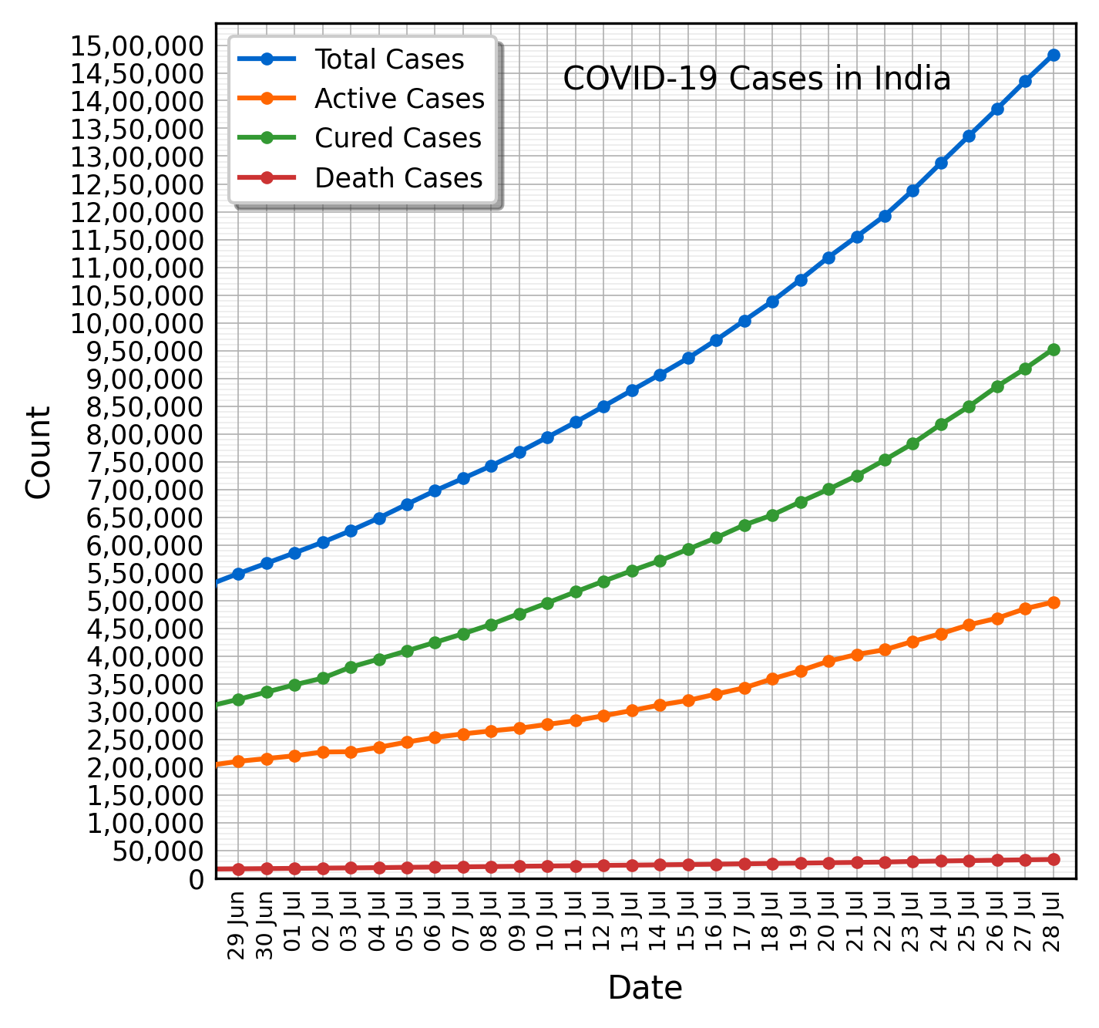
Fig. 1. COVID-19 cases in India as of July 28, 2020 (Source: https://indiacovid19.github.io). Note that “Fig.” is abbreviated. It is good practice to explain the significance of the figure in the caption.
Graphics may be full color. Graphics must not use stipple fill patterns because they may not be reproduced properly. Please use only solid fill colors, which contrast well both on screen and on a black-and-white hardcopy.
There are no specific requirements for header rows, column width, row height, use of borders, etc. Do not use colors in tables. The text in the table must be 8 pt. Figures and tables may be inserted in text boxes, as shown in these examples.
Figure and table captions should follow the guidelines in Table I. When referencing your figures and tables within your paper, use the abbreviation “Fig.” even at the beginning of a sentence. Do not abbreviate “Table.” Tables should be numbered with Roman Numerals.

Math
If you are using Word, use either the Microsoft Equation Editor or the MathType add-on (http://www.mathtype.com) for equations in your paper (Insert | Equation or MathType Equation). “Float over text” should not be selected.
Number equations consecutively with equation numbers in parentheses flush with the right margin, as in (1). First, use the equation editor to create the equation. Then select the “Equation” markup style. Press the tab key and write the equation number in parentheses.
TABLE I
Summary of formatting styles
Section | Style | Detailsª
Title | Title | 24 pt, Bold, centered
Author names | Authors | 11 pt, Centered
Abstract | Abstract | 9 pt, Bold, the word “Abstract” is italicized
Keywords | Abstract | 9 pt, Bold, the word “Keywords” is italicized
JEET Category | Abstract | 9 pt, Bold, the words “JEET Category” are italicized
Heading 1 | 1. Heading I | 10 pt, Centered, numbered (Roman numbers), Small caps
Heading 2 | A. Heading 2 | 10 pt, Left justified, numbered (capital alphabets), Italics
Heading 3 | 1) Heading 3 | 10 pt, Left justified, numbered (Hindu-Arabic numerals with a right parenthesis), Italics
Main text | Text | 10 pt, Both left and right justified
Figure caption | Figure caption | 8 pt, justified, below the figure, Hindu-Arabic numerals
Table caption | Table Title | 8 pt, centered, small caps, above the table, Roman numerals
Header | Header | 9 pt, italics, left justified
Footnote | Footnote Text | 8 pt, justified
Appendix, Acknowledgement, References | Unnumbered Section | 10 pt, centered, Small caps
Bibliography | Bibliography | 10 pt, justified
Vertical lines are optional in tables. Statements that serve as captions for the entire table do not need footnote letters.
ªUse Times New Roman and single line spacing throughout the manuscript.

${\left(x+a\right)}^{n}=\sum_{k=0}^{n}{\left({n \atop k}\right)x^{k}a^{n-k}}$ (1)

Refer to “(1),” not “Eq. (1)” or “equation (1),” except at the beginning of a sentence: “Equation (1) is ... .”

Page Numbers
Do not use page numbers.

Footnotes
It is recommended that footnotes be avoided (except for the unnumbered footnote with the receipt date on the first page). Instead, try to integrate the footnote information into the text. If you absolutely have to, number footnotes separately in superscripts (Insert | Footnote). Use letters for table footnotes (see Table I).

References
JEET uses the American Psychological Association (APA) format for in-text and reference list citations. See a concise guide at www.mendeley.com/guides/apa-citation-guide. It is recommended that you use a citation manager like Zotero or Mendeley. Below are some examples of in-text citations; the references section should only contain the bibliography, i.e., a list of references in the APA format. In-text citations include the last name of the authors and the year of publication only, for example, “Author (year) states…” or “… (Author, year).”
- Books: Creswell (2012) explains the importance of the literature review process.
- Book chapters: Guzdial and du Boulay (2019) summarize the history of computing education research.
- Journal articles: Peer instruction is an active learning technique used successfully in college-level STEM courses (Crouch & Mazur, 2001). When citing multiple works together, separate them by semi-colons like this (Fellah & Bandi, 2018; Hamouda et al., 2019).
- Conference proceedings: Esakia and McCrickard (2016) propose an adaptive model for teaching mobile app development in computing courses.

Structuring your paper
As mentioned above, this document focuses on the formatting of the paper. For guidelines on the contents and structure of the article and review criteria, please visit JEET Author and Reviewer Guidelines.

Appendix
Appendixes, if needed, appear before the acknowledgment.

Acknowledgment
Use the singular heading even if you have many acknowledgments. Leave this section as is for the double-blind review process.

References
Creswell, J. W. (2012). Educational research: Planning, conducting, and evaluating quantitative and qualitative research (4th ed). Pearson.
Crouch, C. H., & Mazur, E. (2001). Peer Instruction: Ten years of experience and results. American Journal of Physics, 69(9), 970–977.
Esakia, A., & McCrickard, D. S. (2016). An adaptable model for teaching mobile app development. 2016 IEEE Frontiers in Education Conference (FIE), 1–9.
Fellah, A., & Bandi, A. (2018). The Essence of Recursion: Reduction, Delegation, and Visualization. Journal of Computing Sciences in Colleges, 33(5), 115–123.
Guzdial, M., & du Boulay, B. (2019). The History of Computing Education Research. In S. A. Fincher & A. V. Robins (Eds.), The Cambridge Handbook of Computing Education Research (1st ed., pp. 11–39). Cambridge University Press.
Hamouda, S., Edwards, S. H., Elmongui, H. G., Ernst, J. V., & Shaffer, C. A. (2019). RecurTutor: An Interactive Tutorial for Learning Recursion. ACM Transactions on Computing Education, 19(1), 1–25.

Leave this section as is for the double-blind review process. Once accepted, you will be asked to make appropriate changes. This paper was submitted for review on Month DD, YYYY. It was accepted on Month, DD, YYYY. Corresponding author: F. A. Author, Department, Institute/University, State, Country. (Do not use titles such as “Dr.”, “Prof.”, or ranks like “Associate Professor,” “Director,” here.) Address: full address with PIN code (e-mail: author@institute.edu). Copyright © YYYY JEET.

