Figure File General Guidelines

- File size: The file sizes should not exceed 20 MB.
Figure submission: Figures should be submitted after uploading the article (in step 4 of the submission process in supplementary files). In case of multiple files, upload the figures in order. E.g., Figure 1 should be uploaded first followed by Figure 2, 3 and so on.
Citation: All figures must be cited in the text and authors should indicate where they are to be inserted in the text.
Figure captions: These have to be included in the text and provided sequentially at the end of the article. The captions should be short having 10-15 words in sentence case style.
E.g., Figure 1. Percentage of detection rate vs. number of nodes.
Permissions: Authors should obtain permission from authors for copyright figures before submitting to Indian Journal of Science and Technology
- All figures will be published under a Creative Commons Attribution License, which allows them to be freely used, distributed, and built upon as long as proper attribution is given.
- Please do not submit any figures that have been previously copyrighted unless you have express written permission from the copyright holder to publish under the CCAL license.

Refer the figure file template given in the next page:

Figures

Figure 1. Reducing ability of Walsura trifoliata root extracts in different concentrations (200–1000 µg/ml) of hexane, ethyl acetate, methanol and vitamin C.

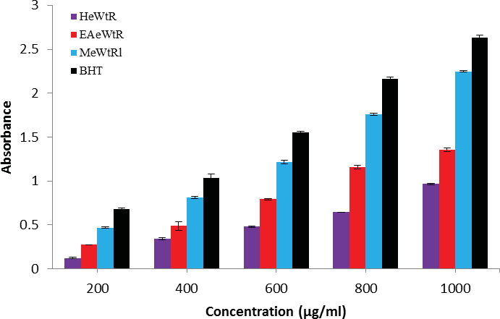

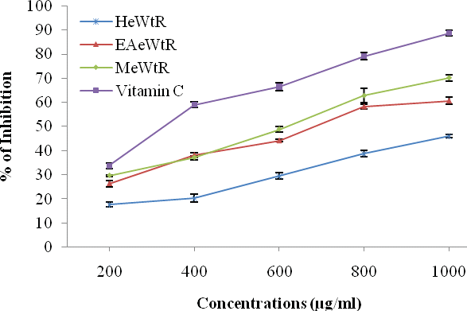
Figure 2. DPPH scavenging effect of Walsura trifoliata root extracts in different concentrations (200–1000 µg/ml) of hexane, ethyl acetate, methanol and vitamin C

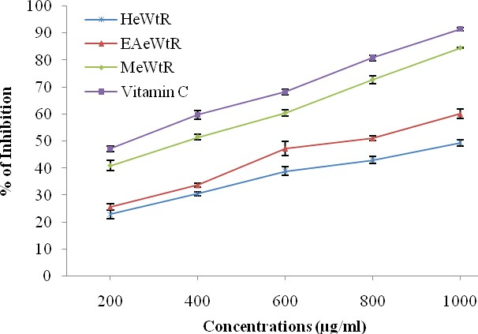
Figure 3. Hydroxyl radical scavenging effect of Walsura trifoliata root extracts in different concentrations (200–1000 µg/ml) of hexane, ethyl acetate, methanol and vitamin C.

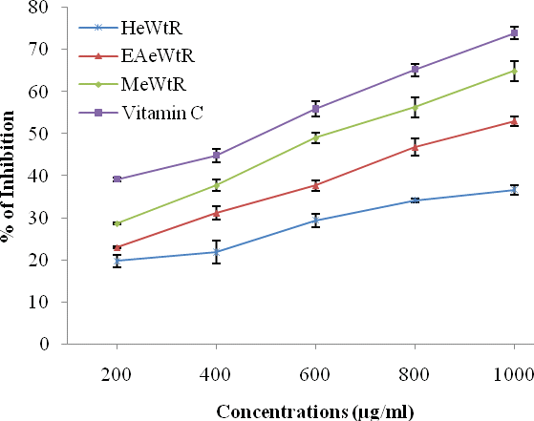
Figure 4. Nitric oxide scavenging effect of Walsura trifoliata root extracts in different concentrations (200–1000 µg/ml) of hexane, ethyl acetate, methanol and vitamin C.

